**Predicting Kickstarter Success**

MSDS 6372: Project 2

Authors: Travis Deason, Yejur Kunwar, and Vanessa Torres

**Abstract**

The success of Kickstarter projects may have some association with the factors like goal, number of backers, amount of money pledged, and few other key features. This research focuses on producing a model that would determine some features to predict success of Kickstarter projects. The methodology includes feature brainstorming, natural language processing, and random forest algorithms. We believe that our model will be helpful in determining and improving success rate of Kickstarter projects.

**Introduction**

The platform to spark ideas, design, share, and start project can be very helpful when projects come to life. Kickstarter is similar platform to bring projects to life through crowdfunding. Many have seen from $100 - $1 billion pledged. However, there are many projects that were not launched.

In this study, we employed various statistical measures to design our model which will try predict success of Kickstarter project accurately. We will leverage random forest algorithm concepts to analyze variables listed in data description alongside with some variables we thought would be interesting to predict outcomes.

**Data description**

The datasets utilized in this study is collection of more than 300,000 Kickstarter projects collected by user named Kemical from Kickstarter platform. The datasets can be downloaded from Kaggle website (<https://www.kaggle.com/kemical/kickstarter-projects>).

The original dataset contains Kickstarter projects from 2016 (ks-project-201612.csv ) and 2018 (ks-project-201801.csv). The ks-project-201612.csv contains 323750 observations with 16 columns and ks-project-201801.csv contains 323750 observations with 15 columns.

However, there were few columns which were mostly empty and are excluded from data description and analysis.

Table 1: Columns and data description

|  |  |  |
| --- | --- | --- |
| **Columns** | **Type** | **Description** |
| ID | Numeric | ID- Kickstarter id |
| name | String | Name of project |
| category | String | Category of project |
| main_category | String | Classification of project type |
| currency | String | Currency |
| deadline | DateTime | Crowdfunding deadline |
| goal | Numeric | Goal amount for fundraising |
| launched | DateTime | Date launched |
| pledged | Numeric | Crowd pledged amount |
| state | String | Status of project |
| backers | Numeric | Number of supporters |
| country | String | Country |
| usd pledged | Numeric | Pledged amount of money |

Furthermore, the details and subcategories for these columns are listed below:

Table 2: Detailed subcategories list

|  |  |
| --- | --- |
| Columns | Values |
| Currency | GBP, USD, CAD, NDK, AUD, EUR, MXN, SEK, NZD, CHF, DKK, HKD, SGD |
| State | failed, successful, live, undefined, suspended |
| main_category | Publishing, Film & Video, Music, Food, Crafts, Games, Design, Comics, Fashion, Theater, Art, Photography, Technology, Dance, Journalism |

The quick look with example of rows and columns after adding some features extracted from NLP(natural language processing) algorithms are listed in images below. We were interested to find out how the noun, adjective, verbs, and other language structures used in titles would help us build most predictive models.

Fig 1: Description of datasets with added features

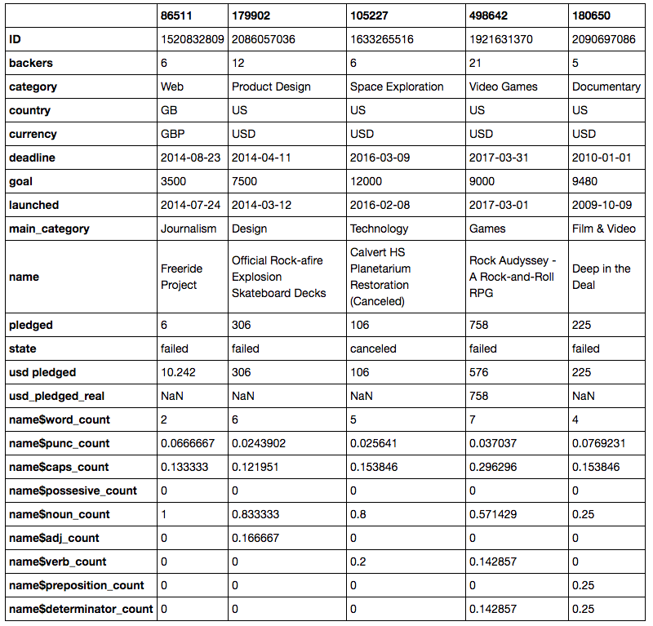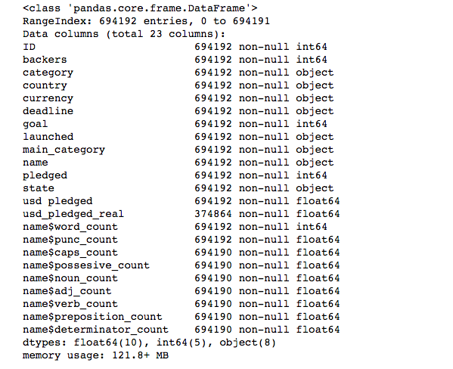

**Exploratory data analysis**

Before we got started with our analysis, we dropped the “Unnamed” columns (4) from the 2016 file, combined both dataset files, replaced the “NAs” to 0 in the “usd pledged” column, and then removed all of the “NAs” from the entire file. In doing so, we took an initial glance at the state variable and found that, more than 55% of the projects had failed.

Fig 2: Count of successful, failed, and other project status



Based on our initial glance, we also found that we could not conclude that a significant difference (p-value= 0.89) existed between the countries and their pledges. Though on the other hand, when we ran a second ANOVA for US pledges only, we found a p-value of 0.04. Furthermore, as a final look, we ran a Tukey and found…

Fig: 3: Multiple comparison between…..((((()))))



- null values and all discussion

- other areas of focus

**Restate problem**

Our team started with simple question which focused around predicting success rate of Kickstarter projects. The dataset suggested over 50% of Kickstarter projects failed or do not reach the successful status. We are primarily focused on utilizing available variables in dataset as well as finding some more feature variables to better predict outcomes.

Models:

Interpretation:

Conclusion:

Appendix: